1. Implementation of grade sheet.

<!DOCTYPE html>

<html lang="en">

  <head>

    <meta charset="UTF-8" />

    <meta name="viewport" content="width=device-width, initial-scale=1.0" />

    <title>Classroom</title>

    <style>

      table, th, td {

        border: 1px solid black;

      }

      th, td {

        padding: 7px;

      }

    </style>

  </head>

  <body>

    <h2>GOBINDA PANDA</h2>

    <h3>Veer Surendra Sai University of Technology, Burla</h3>

    <br />

    <table width="100%">

      <caption>

        Semester 1:

      </caption>

      <tr>

        <th>Sl. No.</th>

        <th>Subject</th>

        <th>Grade</th>

      </tr>

      <tr>

        <td>1.</td>

        <td>Engineering Physics</td>

        <td>A+</td>

      </tr>

      <tr>

        <td>2.</td>

        <td>Basic Electrical Engineering</td>

        <td>O</td>

      </tr>

      <tr>

        <td>3.</td>

        <td>Mathematics</td>

        <td>O</td>

      </tr>

      <tr>

        <td>4.</td>

        <td>Basic Mechanics</td>

        <td>A+</td>

      </tr>

      <tr>

        <td colspan="2">SGPA:</td>

        <td>9.40</td>

      </tr>

    </table>

    <br />

    <table width="100%">

      <caption>

        Semester 2:

      </caption>

      <tr>

        <th>Sl. No.</th>

        <th>Subject</th>

        <th>Grade</th>

      </tr>

      <tr>

        <td>1.</td>

        <td>Basic Chemistry</td>

        <td>A</td>

      </tr>

      <tr>

        <td>2.</td>

        <td>Programming for Problem Solving</td>

        <td>O</td>

      </tr>

      <tr>

        <td>3.</td>

        <td>Workshop Experience</td>

        <td>A+</td>

      </tr>

      <tr>

        <td>4.</td>

        <td>Engineering Drawing</td>

        <td>A</td>

      </tr>

      <tr>

        <td colspan="2">SGPA:</td>

        <td>9.22</td>

      </tr>

      <tr>

        <td colspan="2">CGPA:</td>

        <td>9.31</td>

      </tr>

    </table>

    <br />

    <table width="100%">

      <caption>

        Semester 3:

      </caption>

      <tr>

        <th>Sl. No.</th>

        <th>Subject</th>

        <th>Grade</th>

      </tr>

      <tr>

        <td>1.</td>

        <td>Object Oriented Programming</td>

        <td>O</td>

      </tr>

      <tr>

        <td>2.</td>

        <td>Data Structure</td>

        <td>A+</td>

      </tr>

      <tr>

        <td>3.</td>

        <td>Machine Learning</td>

        <td>O</td>

      </tr>

      <tr>

        <td>4.</td>

        <td>Cloud Computing</td>

        <td>A</td>

      </tr>

      <tr>

        <td colspan="2">SGPA:</td>

        <td>9.14</td>

      </tr>

    </table>

    <br />

    <table width="100%">

      <caption>

        Semester 4:

      </caption>

      <tr>

        <th>Sl. No.</th>

        <th>Subject</th>

        <th>Grade</th>

      </tr>

      <tr>

        <td>1.</td>

        <td>Digital Electronics</td>

        <td>A</td>

      </tr>

      <tr>

        <td>2.</td>

        <td>Computer Architecture</td>

        <td>A</td>

      </tr>

      <tr>

        <td>3.</td>

        <td>Computer Organization</td>

        <td>B+</td>

      </tr>

      <tr>

        <td>4.</td>

        <td>Design Analysis and Algorithms</td>

        <td>O</td>

      </tr>

      <tr>

        <td colspan="2">SGPA:</td>

        <td>9.00</td>

      </tr>

      <tr>

        <td colspan="2">CGPA:</td>

        <td>9.19</td>

      </tr>

    </table>

    <br />

    <table width="100%">

      <caption>

        Semester 5:

      </caption>

      <tr>

        <th>Sl. No.</th>

        <th>Subject</th>

        <th>Grade</th>

      </tr>

      <tr>

        <td>1.</td>

        <td>Database Management System</td>

        <td>O</td>

      </tr>

      <tr>

        <td>2.</td>

        <td>Operating System</td>

        <td>O</td>

      </tr>

      <tr>

        <td>3.</td>

        <td>Graph Theory</td>

        <td>A+</td>

      </tr>

      <tr>

        <td>4.</td>

        <td>Computer Graphics</td>

        <td>O</td>

      </tr>

      <tr>

        <td colspan="2">SGPA:</td>

        <td>9.78</td>

      </tr>

    </table>

    <br />

    <table width="100%">

      <caption>

        Semester 6:

      </caption>

      <tr>

        <th>Sl. No.</th>

        <th>Subject</th>

        <th>Grade</th>

      </tr>

      <tr>

        <td>1.</td>

        <td>Software Engineering</td>

        <td>A+</td>

      </tr>

      <tr>

        <td>2.</td>

        <td>Computer Network</td>

        <td>O</td>

      </tr>

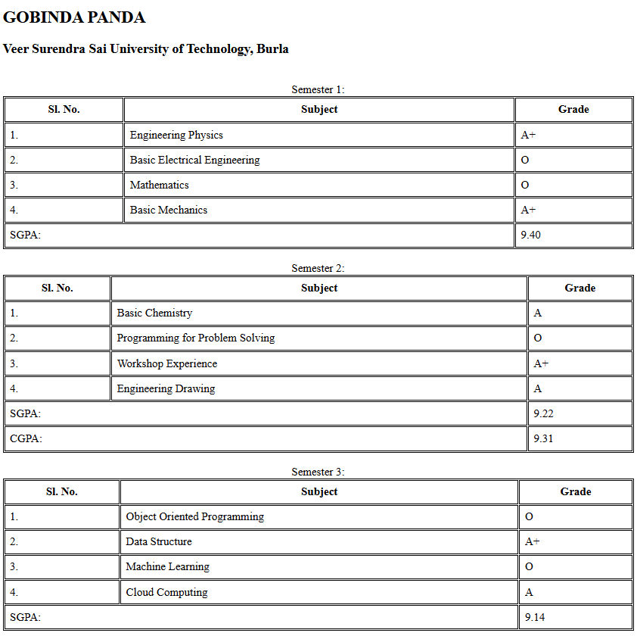

<tr>

        <td>3.</td>

        <td>Theory of Computation</td>

        <td>O</td>

      </tr>

      <tr>

        <td>4.</td>

        <td>Compiler Design</td>

        <td>A+</td>

      </tr>

      <tr>

        <td colspan="2">SGPA:</td>

        <td>9.52</td>

      </tr>

      <tr>

        <td colspan="2">CGPA:</td>

        <td>9.34</td>

      </tr>

    </table>

    <br />

  </body>

</html>

